Strategic Note Taking
Intervention Summary
Strategic notes are used to enhance comprehension of expository text. Students are given written prompts as a guide to help them catch main points and to summarize and organize information. Note taking form is unique to each story which allows the teacher more flexibility in what they want the students to get out of the reading.
Materials Needed
- Reading material
- Strategic note taking form
Procedures
Baseline Data
Students should read passages and answer the ten questions (Table 1) that examine their reading comprehension of that passage. Also, students can be asked to retell the story in their own words, and number words, sentences, or phrases they include can be tabulated. After the baseline data have been collected, plot the data along with the goal line on the chart and give to the teacher to so he/she can plot the weekly progress monitoring data.

Intervention Steps
- After selecting the reading, create a strategic note taking form pertaining to the reading. Make sure to hit address the characters, plot, problem, and solution of the reading.
- Have a training session with the students explaining how to use the note taking form.
- Model the strategic not taking form with a practice reading with “think aloud” to help convey the techniques to the students.
- Have the student complete the form on their own and offer any help if needed.
- Go over and correct any misinformation on the form.
Progress Monitoring
Progress Monitoring should occur once or twice a week having the student answer the ten reading comprehension questions. Review the progress monitoring data each week. If the progress monitoring data points are below the goal line three times in a row, the intervention plan needs to be reviewed to determine if changes in the intervention or goal need to be made. In addition, the intervention implementation checklist should be completed each time it is implemented.

Alternate Ideas/Variations
Students can also use it while the teacher is lecturing to help better organize and comprehend the information. This intervention can be used at Tier 1, Tier 2 or Tier 3.
References
Boyle, J. & Weishaar, M.(2001). The effect of strategic notetaking on the recall and comprehension of lecture information for high school students with learning disabilities. Learning Disabilities Research & Practice, 16(3), 133-141.
Dally, E.J., Chafouleas, S., & Skinner, C.H. (2005). Interventions for reading problems: Designing and evaluating effective strategies. New York: Guilford Press.
Lee, P.L., Lan, W., Hamman D., & Hendricks, B. (2008). The effects of teaching notetaking strategies on elementary student’ science learning. Instructional Science, 36, 191-201.

Example of a Strategic Note Taking Form
FOSSILS
- Fossils are left by…
a.
b.

- Fossils are left by…
a.
b.
c.
d. skeletons
e. hardened tracks or footprints left by a moving animal

- When a plant or animal dies, what happens?
  - It becomes covered by mud or sand
  - As time goes by…
1.
2. Dead plant or animal harden into rock

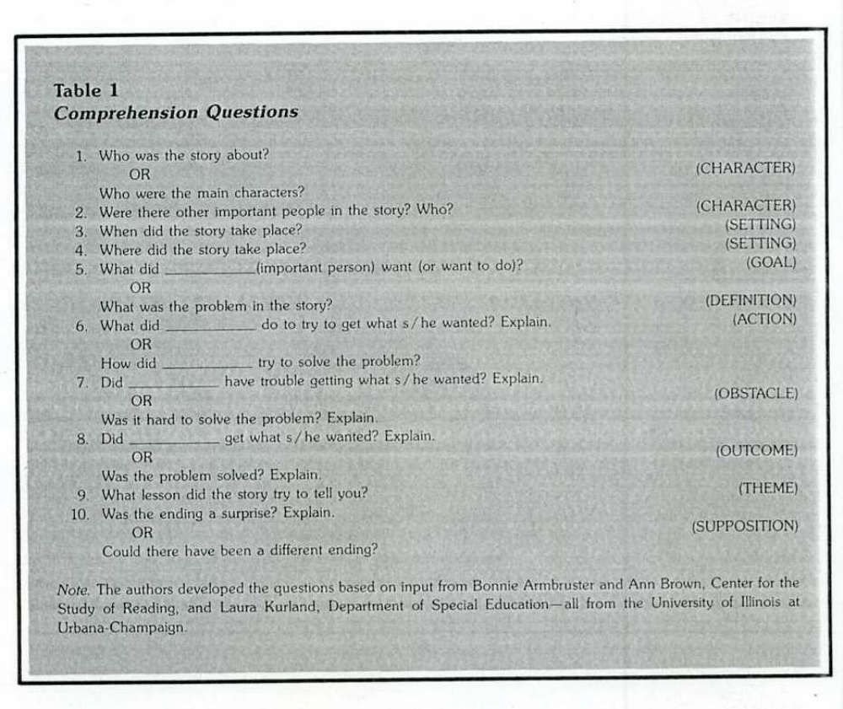

Intervention Implementation Checklist

- Created note taking form Yes or No
- Explained how the form is filled out Yes or No
- Model edthe form with a practice reading Yes or No
- Had student fill out form on their own Yes or No
- Went over form with student Yes or No

